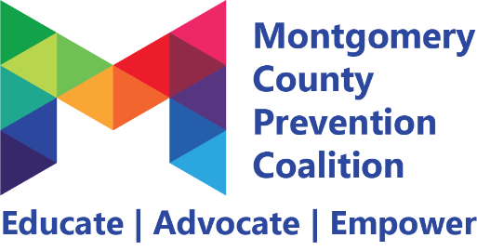

Alcohol Prevention Committee Meeting Minutes
August 8, 2022 1:00PM – 2:30PM
Virtual Meeting
Minutes

1. Welcome & Introductions: Introductions
- Attendees: Kyle Fowler; Karen Via, Taniyah O'Quinn-Sims, Michelle Johnson, Zola Howard and Steve Makofka.
- Guests indicated below: N/A
- Read the Personal Agreement with members

2. Professional Development:
- There was no training today – rescheduled the Public Health presentation to September.
- We will conduct the panel in October – with help from Tara and the Oregon District Businesses

3. Retailers Care Update:
- Taniayah shared they received deliverables for this project.
- Next meeting September 17th – will be scheduling opportunities to conduct visits to retailers among people who agreed to help.

5. Mission Statement Brainstorming:
- The mission statement was finalized and will be sent to Danielle to post.

6. Committee work:
- Marketing/Communication/PR
  - Committee agreed that our information for the website would have 4 focus areas: Parents/Caring Adults/Teachers, Youth, Teens, College Students/Young Adults. And several graphics will be included on the page for General audience.
  - Karen will send out a packet of ideas and links for the website with this being the final opportunity to enter ideas.
  - Members are encouraged to look at these resources and we will discuss before next meeting.
- Briefly gave update on what is happening in Huber Heights and waiting for state to schedule reviewing hearing.
- Decided that October will be the bar/restaurant panel and November we will try to get with youth to find out what hey are doing.
- We will ask more information about the alcohol-free event ideas of other committees.

