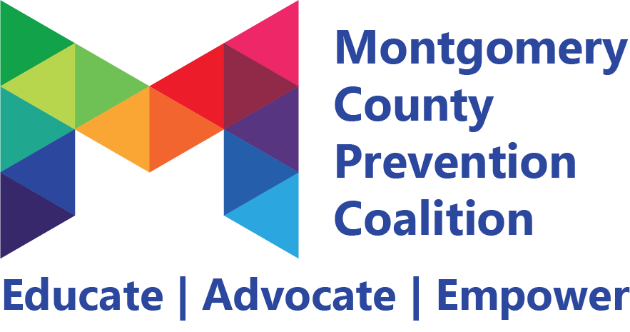

2024-2025 Strategic Action Plan
Suicide Prevention
Measurable Activity | How will we measure this? | Who is responsible? | By When? | Progress (COMPLETED, IN PROGRESS, ON HOLD, NOT STARTED) | Project Team Needed?
Assist 2 employers in creating mental health days (outside of normal PTO) for employees. | - Letters to unions  - List of those who do already  - #of changes written into policy | Premier Health, Goodwill Easter Seals Miami Valley, Omega CDC, Dayton Metro Library | August 2025
Support 2 schools or districts in working with the ESC to make policy changes that focus on restorative practices. | #of contacts with school administration  spreadsheet?  Cohorts already versus final | Montgomery County Educational Services Center, Dayton Children’s Hospital | July 2025

Power-Based Violence Prevention

Measurable Activity | How will we measure this? | Who is responsible? | By When? | Progress (COMPLETED, IN PROGRESS, ON HOLD, NOT STARTED) | Project Team Needed?
Educate 10 elected officials on best practices in rent control and safe housing access for survivors. | of contacts with officials (spreadsheet?) |  | December 2025
Reach out to 7 elected officials to advocate for implementing a local policy creating accountability for schools in implementing Erin’s Law. | Spreadsheet/report out at P&A meetings | Dayton Children’s Hospital, Family Services Association | December 2025

Self-Care
Measurable Activity | How will we measure this? | Who is responsible? | By When? | Progress (COMPLETED, IN PROGRESS, ON HOLD, NOT STARTED) | Project Team Needed?
Raise awareness for mental health concerns for youth, addressing 1 piece of legislation that has a committee hearing.  Provided written testimony for Andrea White’s bill requiring 988 to be on student IDs, planners and on school website | Excel Doc to track all pieces of legislation concerning youth or file with correspondence | Family Services Association, Dayton Children’s Hospital | End of the legislative session  December 31 2024  *2025 goal will go into 2026* | COMPLETED
Create legislative brief for 32 school buildings in response to HB 68 (gender-affirming care) | Excel tracking form | Dayton Metro Library | June 2025 | IN PROGRESS

Gaming & Gambling

Measurable Activity | How will we measure this? | Who is responsible? | By When? | Progress (COMPLETED, IN PROGRESS, ON HOLD, NOT STARTED) | Project Team Needed?
Create sample policy for schools to implement an age requirement for youth to assist with any gambling-related fundraising activities, supporting 10 schools. | Excel tracking form |  | June 2025
Create and send a letter of support for the NCAA against college-level sports betting in Ohio. | Development of the letter |  | December 2024 (complete in 2024 and send to new General Assembly in 2025) | ON HOLD

Opioid Prevention

Measurable Activity | How will we measure this? | Who is responsible? | By When? | Progress (COMPLETED, IN PROGRESS, ON HOLD, NOT STARTED) | Project Team Needed?
Work with 7 Montgomery County elected officials to advocate for a mandatory physician check-in after prescribing opioids | Spreadsheets, report outs at MCPC meetings |  | March 2025 (have time to communicate with new elected officials)
Send issue brief to pass Opioid Warning sticker policy at the state level | Sending outing the letter again | Dayton Children’s Hospital, Montgomery County Commission | April  2025

Cannabis & Alcohol Prevention

Measurable Activity | How will we measure this? | Who is responsible? | By When? | Progress (COMPLETED, IN PROGRESS, ON HOLD, NOT STARTED) | Project Team Needed?
Submit letter of objection to new liquor license proposed in Old North Dayton, as requested by the Old North Dayton Neighborhood Association | Letter sent to City of Dayton | Montgomery County Commission, East End Community Services, Old North Dayton Neighborhood Association, Montgomery County Educational Services Center | September 2024 | COMPLETED

