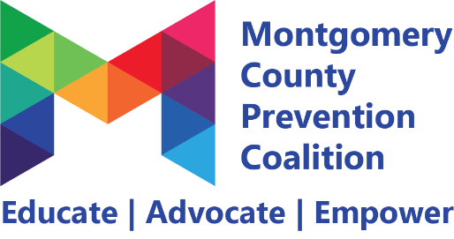

Montgomery County Prevention Coalition

Personal Agreement

As a member of the Montgomery County Prevention Coalition (MCPC), I understand the need for respectful collaboration between all members. As a growing, diverse community coalition, I understand and value our differences. This valuing of diversity can only take place when we have a safe space where everyone is welcome to have brave conversations.

I know that everyone is here because they want to advance the mission of the MCPC to prevent substance use and promote mental wellness. We are all part of the MCPC and represent the communities that we live in and serve.

I understand that we are all human and have diverse skills and knowledge in building inclusive communities. Everyone's unique experiences and backgrounds make us better as a coalition.

Growth from within can be difficult. With the support of other coalition members, I am able to examine my personal biases, understand the perspectives of others and broaden my understanding of people who are different from me.

I take responsibility for:
- Entering discussions and meetings from a place of curiosity
- Assuming good intentions
- “Calling in” other members of the Coalition and offering feedback without shaming or judgement
- Asking clarifying questions before reacting
- Recognizing and struggling with my own sensitivities
- Respectfully communicating concerns
- Respecting the confidentiality of all personal information shared by coalition members

We are better and stronger when we work together.

[Created by the National Conference for Community and Justice in partnership with the MCPC]

