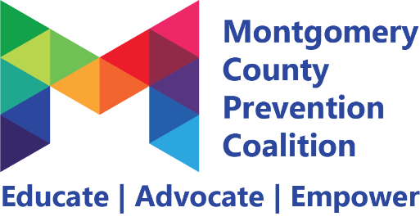
Self-Care Committee
Minutes
April 14, 2022 2-4pm via Zoom

Meeting minutes

Attendance
Janeece Warfield, Wendy Berkshire, Sanjii Johnigan, Ralph Davis, Nina Rains, Emily Sewall, Kayla Hairston, Colleen Oakes, Ashley Browning, Asiaonna Eley, Kelly Howard, Madison Dave, Sasha May, Tazeen Ahmed

- Personal Agreement Kayla Hairston 5 minutes
- Janeece read aloud. Thank you!

- Welcome/Introductions Whole Group 5 minutes

- Mindfulness Minute Kayla Hairston 10 minutes
- Check in

- Updates on School Initiative School Workgroup 45 minutes
- Grant funding cannot purchase gift cards
- We want the self-care bags to be more focused on teachers rather than on classroom
supplies
- Colleen with follow up with contacts for the YLP Steering Committee
- YLP was the focus of the teacher appreciation card project
- Additional discussion
- Supplies needed to accomplish goals
- Masks, Lysol wipes, cleaning supplies, ink pens, snacks, gift cards,
coffee, tea bags, bottled water, hand lotion/sanitizer, mints, affirmation
sheets, certificate for a meal, coloring book/journal
- Soft barriers committee is creating 5,000 self-care bags and a lot of the items
we are considering are included
- Contact Lake and ask to participate in bagging and also in using the kits for our project
- Schools who received first self-care kits are Vandalia, Wayne and Weisenborn, West Carrollton, Miamisburg, Horizons, Trotwood, Dayton STEM
- Additional schools to focus on:
- Ashley Browning has a relationship with Charity Adams (DPS)
- Emily said West Carrollton is in a transition, adding 5th grade to middle school
- Sanjii said Dayton Smart has 15-20 staff members we could support – 5 are
considering leaving the profession
- Asiaonna said Dayton Leadership Academy and Dunbar HS
- Janeece said Meadowdale
- Kelly Howard said City Days
- Which schools in Trotwood received bags – many different schools – Ralph
Davis is connected to Westbrooke Village Elementary
- Mad River Schools
- At this time we plan to support an additional 3 schools with the self-care bags:
- Dayton SMART – Sanjii will be point of contact
- City Days – Kelly Howard will be point of contact
- Trotwood – Madison (Westbrook) – Ralph Davis will be point of contact

- Updates on Local Help Now App Resource Workgroup 45 minutes
- List of resources https://docs.google.com/spreadsheets/d/1j1qjaKLdvqnZYMGklbRmp3GNFUeWVi9e/edit#gid=53865133
- Will we add the wheel or lists or links
- Should we show a wheel or a definition
- We already have so many resources
- Self-care survey? We may need to come up with our own survey to help guide our definition of self-care
- Instead of limiting self-care to a definition, share quotes about what self-care means to you
- Everyone give a one to two sentence definition of what self-care means to them or ask one community member and share next month
- Define the science behind mindfulness
- Do not include links that could be “dated” or are not reputable
- Remember that the digital detox list has a lot of activities already created

- Coalition Updates Whole Group 10 minutes
- Next Wednesday is the volunteer appreciation event – Wed April 20th – Drive-thru
Event – cookies, hot chocolate, MCPC swag and professional headshots –
Please register!
- May 2nd is the suicide prevention barber and cosmetology event
  - https://www.mcadamhs.org/alert_detail.php
- May 6th from 10-12 is our full coalition meeting at Dayton Metro Library or join via zoom
- YLP application period is open – offer up to $10,000 for youth led peer to peer programming

Commitments
- For the school workgroup – provide school names and staff numbers who could benefit from self-care bags
- Reach out to the soft barriers committee to see if they would like to partner with us – Set a special meeting time to build the kits as May is fast approaching
- For the Local Help Now group – share a quote either from yourself or a community member

Next Meeting May 12, 2022 from 2-4pm via Zoom

